Patel's Analog and Digital Measurement Co. Pvt. Ltd,
A/6 Functional Electronic Estate, Bhosari Indl. Area, Pune- 411026.
Tele: (020) 27120290/ 27120324, Fax: (020) 27122043
E-mail: padmco@vsnl.net , Arleen@dataone.in
_________________________________________________________________________________________________
Inquiry Form-Bushing Winding Machine
Please provide the requested information:
If engineering drawings are available, please send these with your enquiry.
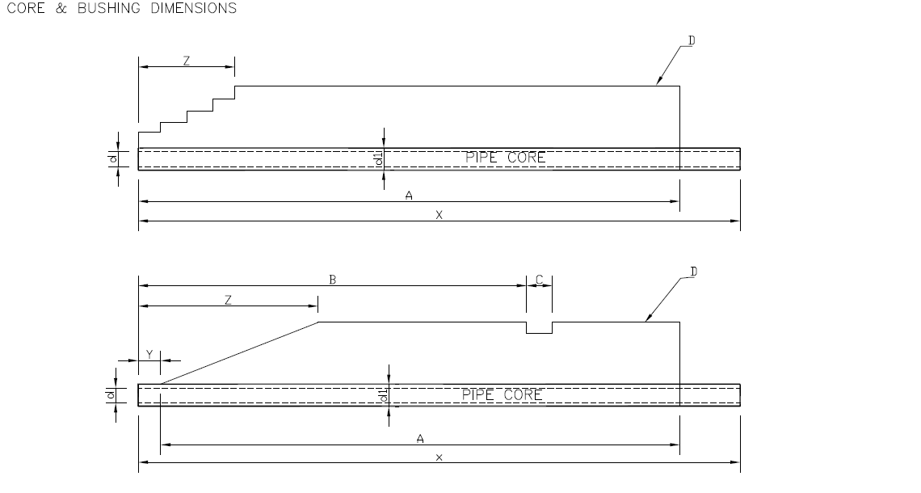
Please fill your following information
Company name :
Company website, :
Company E-mail ID :
Company Contact No.
CB Core & Bushing Dimensions [Typical]
CB | d  (mm) | d1  (mm) | X  (mm) | Y  (mm) | Z  (mm) | A  (mm) | (mm) | B  (mm) | C  (mm) | D  (mm)
KV Class | Pipe ID | Pipe OD | Pipe Length | Distance b/w pipe end and paper start | Step Length | Bushing Paper Width | Paper Roll Width | Tap Cutter position from pipe end | Tap Width | Diameter of wound job

CT Core & Bushing Dimensions [Typical]
CT | d  (mm) | d1  (mm) | X  (mm) | Y  (mm) | Z  (mm) | A  (mm) | (mm) | B  (mm) | C  (mm) | D  (mm)
KV Class | Pipe ID | Pipe OD | Pipe Length | Distance b/w pipe end and paper start | Step Length | Bushing Paper Width | Paper Roll Width | Tap Cutter position from pipe end | Tap Width | Diameter of wound job

